**LEBANESE AMERICAN UNIVERSITY**

**USAID – HIGHER EDUCATION SCHOLARSHIP PROGRAM**

**HES - Volunteering Program Verification Form**

This form is to be used to document volunteering hours. If a student volunteers for multiple organizations, a separate form must be used for each organization. **This form must be turned in by the 28th of each month, the latest.**

I certify that the scholar Nada Holo Nashawati completed a total of 2 hours of service at InnovaThrive.

The hours were completed hours as per the below:

Hours # 0 (date) _2/12 – 6/12_ (initials of supervisor) __A.K.___

Hours # 0 (date) _9/12 – 13/12_ (initials of supervisor) __A.K.___

Hours # 0 date) _16/12 – 20/12 (initials of supervisor) __A.K.___

Hours # 2 date) _23/12 - 27/12 (initials of supervisor) __A.K.___

Brief description of the activities the scholar performed or participated in:

I did full research on the following topic ideas:  
The Role of Artificial Intelligence in Sports Analytics  
  
• Challenges:  
  
• Ensuring data integrity and accuracy.  
  
• Future Research:  
  
• New frontiers in Al for sports performance optimization.

Written feedback about the scholar’s performance:

Nada Holo Nashawati’s research into AI in sports analytics was concise yet effective, addressing key challenges and laying the groundwork for future AI applications in sports performance.

Please rate the overall performance of the scholar at your organization:

|  |  |  |  |
| --- | --- | --- | --- |
|  | Mastery (5) | Proficient (3) | Emerging (1) |
| **Problem solver** | X |  |  |
| **Engaged & Committed** | X |  |  |
| **Open-minded & multicultural** | X |  |  |

Signature

& stamp

__________________________

_

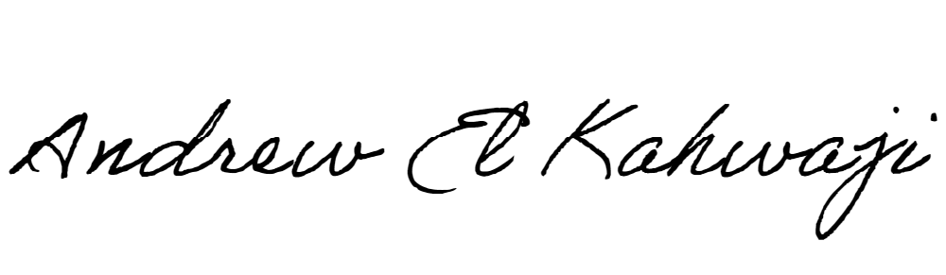

Printed Name _Andrew El Kahwaji_

Date __26/12/2024___

Email __andrew.lifesculptor.coo@gmail.com __

Phone __+961 71 914 378__